TEAM ID : PNT2022TMID30774

# SPRINT DELIVERY 1

**ESTABLISHING THE TEXT-TO-SPEECH SERVICE**

1. **INSTALLATION OF WATSON VERSION**

**CODE:**

pip install –upgrade “ibm-watson>=6.1.0”

**RESULT:**

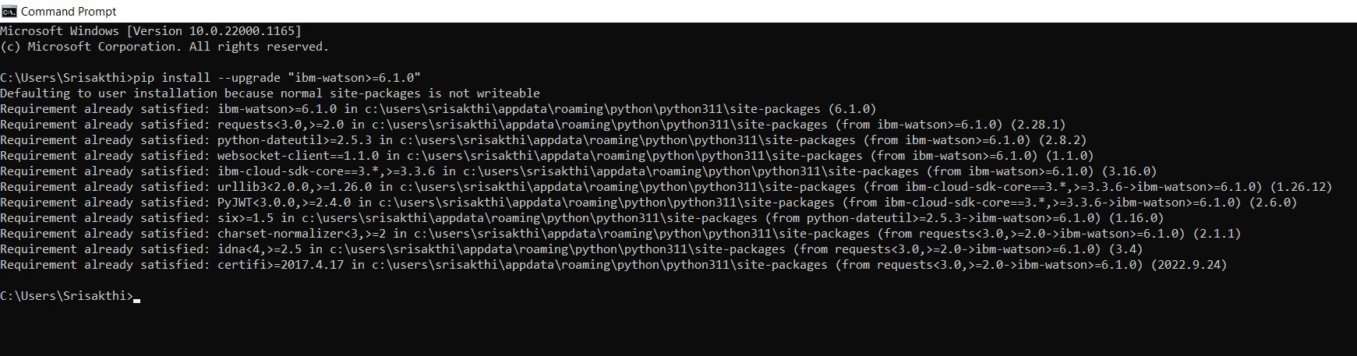

1. **INSTALLATION OF GTTS**

**CODE:**

pip install gtts **RESULT:**

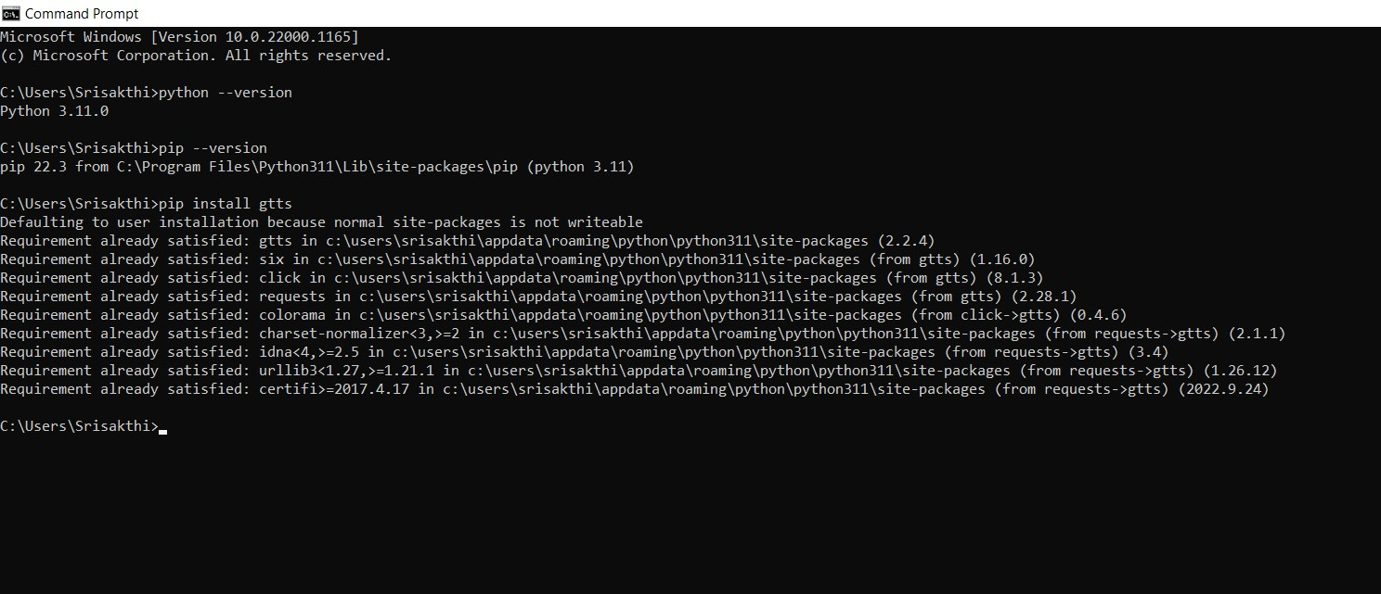

1. **PROGRAM FOR TEXT TO SPEECH CONVERSION:**

**CODE:**

from gtts import gTTS import os fh=open("test.txt","r") myText=fh.read().replace("\n", " ") language='en' output=gTTS(text=myText, lang=language, slow=False) output.save("output.mp3")

fh.close()

os.system("start output.mp3")

1. **PROGRAM EXECUTION:**

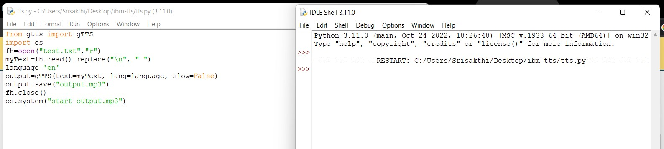

1. **TEXT FILE:**

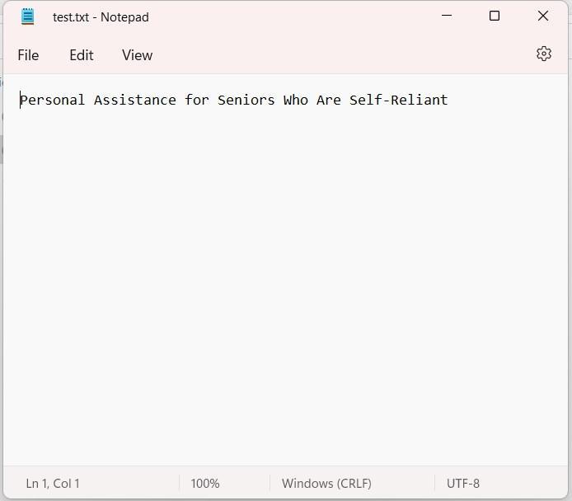

1. **RESULT:**

**VIDEO:**

https://drive.google.com/file/d/1rvWVo7NRYgLNMxqtW_3pQ2yF953R2O3d/view?usp=driv esdk